

Technical Documentation


Mukesh Infoserve Communication Engine -MICE

Table of Contents
Dependencies 3
Database Schema – Web_Mice 3
URLs 6
HTML Fragment & Pages: 7
Project Structure 7
Package Structure: 7

Dependencies
Back-end | UI
- Java 11  - Spring Boot 2.2.5  - Quartz Scheduler  - Lombok 1.18  - Thymeleaf  - SQLite*, Hana & SQL Server Database Drivers | - jQuery  - Materialize.css  - alasql.js  - jScroll  - jCron  - Sweet Alert  - IBM Plex Font  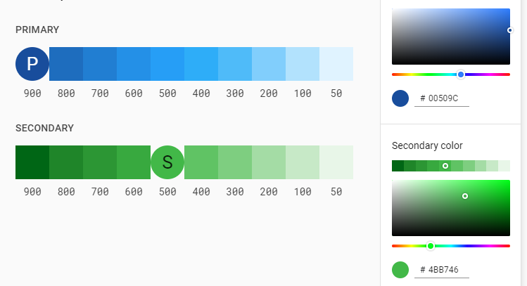

Database Schema – Web_Mice
Table Names | Columns | Comment
APP _USER |  | User master of the Application
  Column | Data Type | Length | Constrains | Comment
APP_ROLE | Standard Table | Roles master
USER_ROLE | Standard Table | User-Role Allocation
job |  | Master of Jobs to be run
  Column | Data Type | Length | Constrains | Comment
  id | int |  | Primary Key
  name | varchar | 255 |  | Name of job
  is_custom_job | boolean |  |  | 0-Built In  1 – User created
  trigger_type | varchar | 255 |  | CRON  SAP
  trigger_exp | varchar | 255 |  | CRON Expression or SAP Doc Type
  has_conditional_check | boolean |  |  | has any conditions to check before sending SMS & Email
  has_sms | boolean
  sms_to | varchar | 255
  sms_text | text
  has_email | boolean
  email_to | text
  email_cc | text
  email_bcc | text
  email_subject | varchar | 255
  email_body | text
  has_report | boolean
  report_query | text
  report_attachment_type | varchar | 10 |  | NULL  INLINE  PDF  EXCEL
  is_active | boolean
  created_on | Timestamp
  updated_on | Timestamp
templates |  | Version 2.0  Stores SMS, Email templates
  Column | Data Type | Length | Constrains | Comment
  id | int |  | Primary Key
  name | Varchar | 255
  text | Text
  type |  |  | not null | SMS or EMAIL
  created_on | Timestamp
  updated_on | Timestamp
report_queries |  | Version 2.0  Contains Query of Reports needs to be executed
  Column | Data Type | Length | Constrains | Comment
config |  | Configuration settings stored as Key-Value Pairs
  Column | Data Type | Length | Constrains | Comment
  Key | Varchar | 255 | Primary Key
  Value | Varchar | 255
mail_queue |  | Contains Queue of Mails to be sent & History
  Column | Data Type | Length | Constrains | Comment
  id | int |  | Primary Key
  job_id | int |  | Foreign Key
  from | varchar | 255
  to | varchar | 255
  cc | varchar | 255
  bcc | varchar | 255
  subject | varchar | 255
  body | text
  has_attachment | boolean | 1 |  | Y – Yes  N - No
  status | char | 1 |  | P- Pending  S-Success  F - Failed
  retry_count | tinyint |  | unsigned
  created_on | Timestamp
  updated_on | Timestamp |  |  | On update
mail_attachment |  | Contains Mail attachment path
  Column | Data Type | Length | Constrains | Comment
  id | int | 255 | Primary Key
  mail_queue_id | int |  | foreign Key
  path | varchar | 255 |  | Attachment path
sms_queue |  | Contains Queue of SMS to be sent & its History
  Column | Data Type | Length | Constrains | Comment
  id | int |  | Primary Key
  job_id | int |  | Foreign Key
  from | varchar | 255
  to | varchar | 255
  body | text
  status | char | 1 |  | P- Pending  S-Success  F – Failed
  retry_count | tinyint | 128 | unsigned
  created_on | Timestamp
  updated_on | Timestamp |  |  | On update
job_history
  Column | Data Type | Length | Constrains | Comment
  id | int |  | Primary Key
  job_id | int |  | foreign key
  sms_status | char | 1
  email_status | char | 1
  sms_error | text
  email_error | text
  created_on | Timestamp

URLs
Group | HTTP | URL Path | Description | Controller | return
Auth | GET | /login | Login page | LoginController | Login.html
Auth | GET | /logout | - | - | Redirect: /login
User | GET | /user | List of Users & Management |  | Users.html
User | POST | /user | Create Users |  | Redirect:/user
Templates | GET | /template/sms | List SMS Templates |  | TemplateSMS.html
Templates | POST | /template/sms | Create SMS template |  | Redirect:/template/sms
Templates | GET | /template/delete/{template_id} | Delete an SMS or Template. {template_id}- Template ID
Templates | GET | /template/email | List Email Template |  | TemplateEmail.html
Templates | POST | /template/email | Create Email template |  | Redirect:/template/email
Jobs | GET | /job | List of Jobs |  | Jobs.html
Jobs | POST | /job | Create a Job |  | Redirect:/job
Jobs | POST | /api/job/update | Update a Job | ApiController | JSON: ResponseDAO
Jobs | POST | /api/delete/{job_id} | Delete a Job | ApiController | JSON: ResponseDAO
Triggers | GET | /api/job/{job_id}/trigger | Get trigger List for the {job_id} | ApiController | JSON: Trigger
Triggers | POST | /api/job/{job_id}/trigger | Create new Trigger for Job Id {job_id} | ApiController | JSON: ResponseDAO
Triggers | POST | /api/trigger/update/{trigger_id} | Update the Trigger Id with {trigger_id} | ApiController | JSON: ResponseDAO
Triggers | GET | /api/trigger/delete/{trigger_id} | Delete the trigger with {trigger_id} | ApiController | JSON: ResponseDAO
History | GET | /api/history | Get List of Job running History | ApiController
History | GET | /api/history/job/{job_id} | Get List of Entries of the {job_id} | ApiController

HTML Fragment & Pages:
Pages | Fragments
- Login.html  - Users.html  - TemplateSMS.html  - TemplateEmail.html  - Jobs.html | - Header.html  - Head.html  - Footer.html  - AddUserModal.html  - AddTriggerModal.html  - ShowHistoryModel.html  - DeleteTriggerModal.html  - AddSMSTemplateFragment.html  - AddEmailTemplateFragment.html

Project Structure
Package Name & Artifact ID : mipl.app.mice

Package Structure:
default | event
- Application  - ServletInitializer  - Scheduler  - void checkSapEntries() => EventPublisher  - void triggerChecker() => EventPublisher  - void sendEmail()  - void sendSms()  - void retryEmail()  - void retrySms() | - SapEvent<SapDocType,SapDocEntry,CRUD>  - CronEvent<JobID>

controller | model | Service
- HomeController | - AppUser  - AppRole  - Jobs  - Config  - MailQueue  - MailAttachment  - SmsQueue  - JobHistory | - UserServiceDetail  - JobService  - add(Job)  - update(Job)  - activate(jobid)  - deactivate(jobid)  - delete(jobid)  - execute(JobId) <= CronEvent Listener  - execute(SapDocType,SapDocEntry,CRUD) <= SapEvent Listener  - addTrigger(JobId,Trigger)  - addReport(JobId,Report)  - MailService  - retry()  - queue(from,to,sub,mail,attachment)  - send(from,to,sub,mail,attachment)  - test()  - SmsService  - retry()  - queue(no,text)  - send(no,text)  - test()  - ParserExecuterService  - parseSms(job_id,sap_document,doc_id)  - parseEmail(job_id,sap_document,doc_id)  - execute(query)

